1. start.spring.io

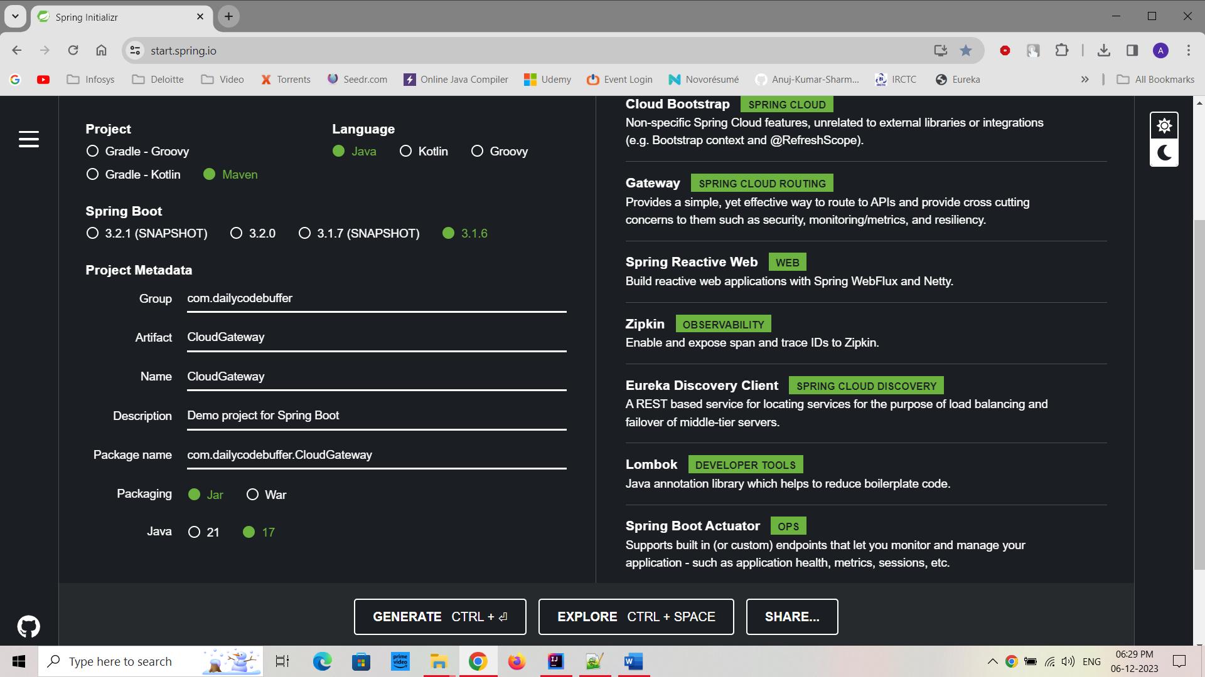

1. application.yaml

(this below part is same)

server:  
 port: 9090  
   
spring:  
 application:  
 name: API-GATEWAY  
 config:  
 import: configserver:http://localhost:9296

(new Part for routing the other services to APIGATEWAY)

spring:  
 cloud:  
 gateway:  
 routes:  
 - id: ORDER-SERVICE  
 uri: lb://ORDER-SERVICE  
 predicates:  
 - Path=/order/\*\*  
 - id: PRODUCT-SERVICE  
 uri: lb://PRODUCT-SERVICE  
 predicates:  
 - Path=/product/\*\*  
 - id: PAYMENT-SERVICE  
 uri: lb://PAYMENT-SERVICE  
 predicates:  
 - Path=/payment/\*\*

